Windows Hints Computer and Technology 10 3 2023
Screenshots
Press the key to copy the screen into the clipboard.
Or
Press the key and the key to save the screen to a file.
More control over portions of the screen to copy can be done using the Windows Snipping Tool. The result of both methods is to put the screen image into the clipboard.
Icons and Shortcuts
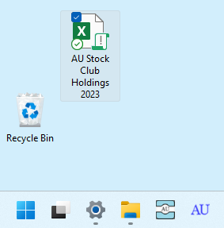
ICONS on the TASKBAR
Shortcut

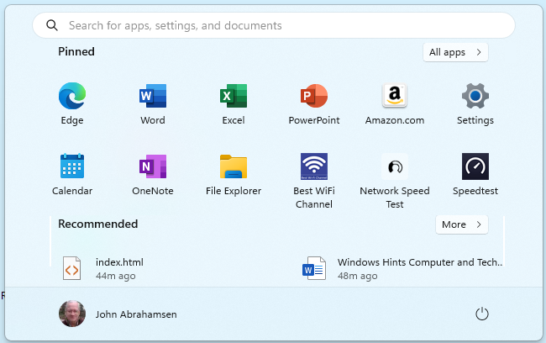
ICONS on START
Create a Shortcut
Open File Explorer
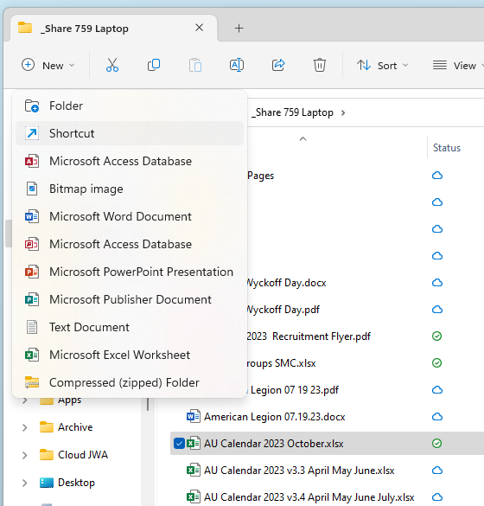
3. Click Shortcut
- Highlight file
2. Click New menu

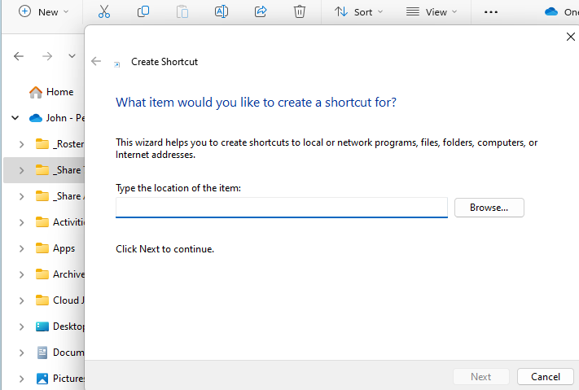
Click and find file to shortcut
After identifying the file CLICK next. Once the shortcut has been created drag it to the desktop.
Add on Icon to Desktop
In “All apps” click on the Icon of interest (in this case the File Explorer Icon)
Then Right Click that Icon to see the drop-down menu. Note that if you want “Pin to taskbar” you must click More >
“Pin to Start” adds that Icon to your start (Pressing key shows the start window)
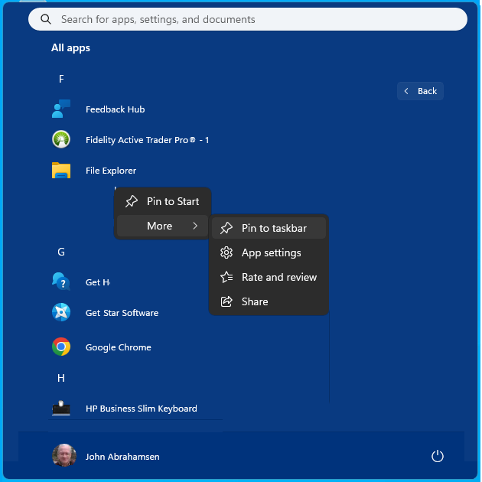
And or Click
Then Click
Click
Desktop
“Pin to taskbar” adds that Icon to your taskbar
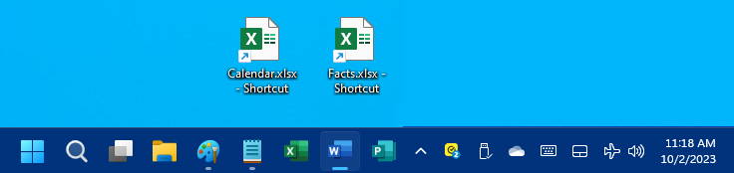
taskbar
Clipboard
Highlighting text or images then using either CUT or COPY will put that into the clipboard. The PASTE will take the LAST IN copied item and paste that. Or if you open the clipboard and CLICK a specific item that will be pasted.
Go to the System settings and turn on the clipboard history.

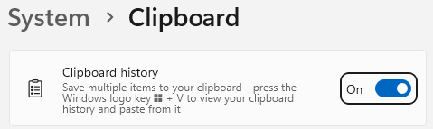
To open your clipboard to see what’s in it or make changes press key and key

This window should appear:
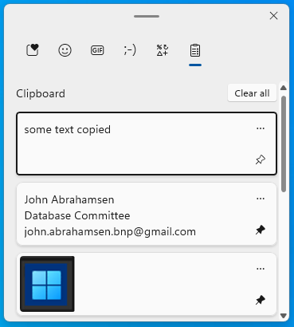
Use scroll to see everything
Click PIN makes it permanent
Click to paste
Click icon

Click the BUTTON “Clear all” to empty the clipboard. However, PINNED boxes will not be erased.
Edge
Open the internet webpage of interest. You can PIN pages to start and taskbar.
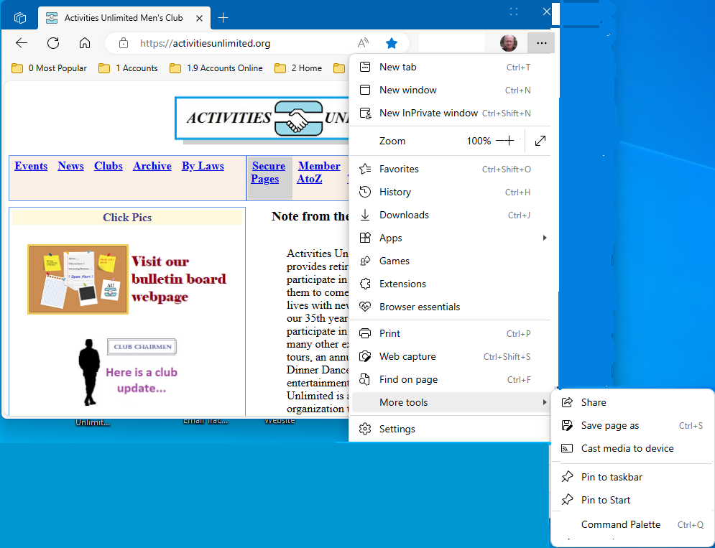
Click desired PIN
Click More tools
Click . . .

The result will be the same as if an APP Icon was pinned.

Appears at the rightmost spot on the taskbar

Drag and drop the taskbar Icons to organize them as per your interests.

Open the internet webpage of interest. You can create Favorite pages.

Click the STAR to create

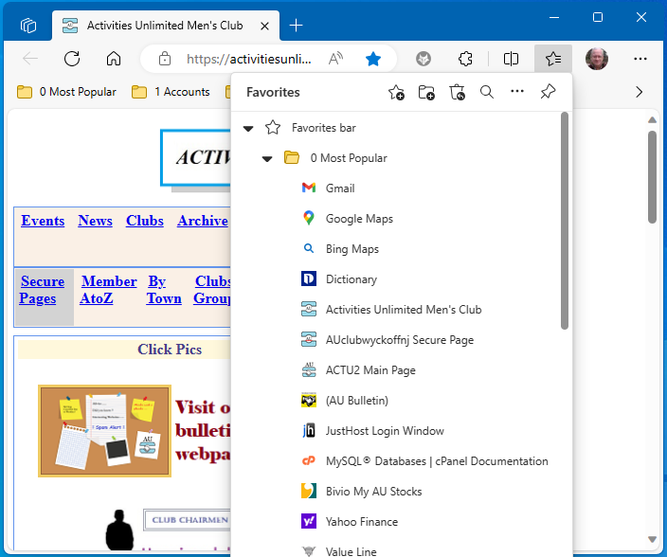
Click here to show the MENU

Click a link on a webpage referring to a Word document.
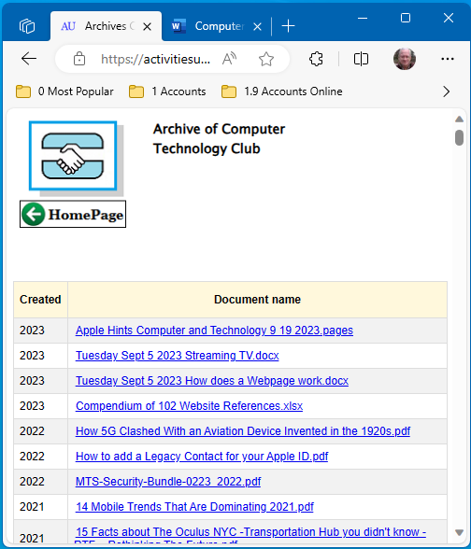
Click on a Word DOC link
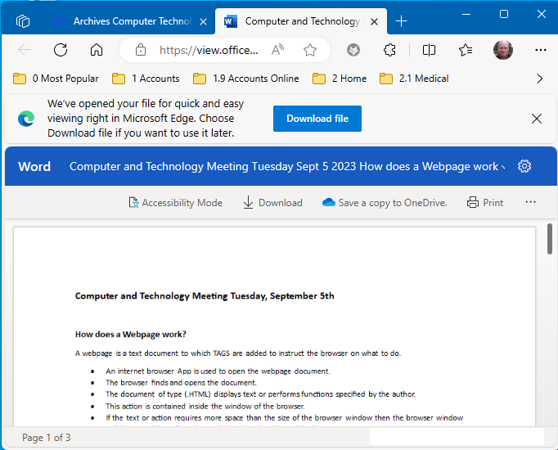
Open and Print on PCs without MS Office

